

|  |  |
| --- | --- |
| **NAME** | **AARYAN SINHA** |
| **ROLL NUMBER** | **20051796** |
| **SECTION** | **CSE-17** |
| **ASSIGNMENT NUMBER** | **6** |
| **ASSIGNMENT TOPIC** | **CONSTRUCTOR** |

**START**

**QUESTION 1 -**  Implement a class Point having data members x and y. Include the following constructors

1. Point()
2. Point (int,int)
3. Point(Point)
4. findDistance() distance from orgin (0,0)
5. findDistance(int x1,int y1) distance from orgin (x1,y1)
6. findDistance(Point p1) distance from p1
7. void show() display the data members x and y.

Also implement an application class PointDemo

where the functionality of Point class is tested.

* **CODE FOR QUESTION 1:-**

class point

{

int r,s;

// private data members

point(){

r=s=0;

}

point(int a, int b)

{

r=a;

s=b;

}

point(point z)

{

r=z.r;

s=z.s;

}

float finddistance()

{

// fd to bbe calculated from the distance(0,0)

float fd = (float)Math.sqrt(r*r+s*s);

return fd;

}

float finddistance(int r1, int y1)

{

// fd to bbe calculated from the distance x1,y1

float fd = (float)Math.sqrt((r-r1)*(r-r1)+(s-y1)*(s-y1));

return fd;

}

float finddistance(point z)

{

// fd to bbe calculated from the distance of point type

float fd = (float)Math.sqrt((r-z.r)*(r-z.r)+(s-z.s)*(s-z.s));

return fd;

}

void show(){

System.out.println("Value of r-coordinate : "+r);

System.out.println("Value of y-coordinate : "+s);

}

}

public class PointDemo{

public static void main(String args[]){

point p1 = new point();

point p2 = new point(9,3);

point p3 = new point(p2);

System.out.println("-----------------");

System.out.println("For P1 object");

p1.show();

System.out.println("-------------------------");

System.out.println("For P2 object");

p2.show();

System.out.println("--------------------");

System.out.println("For P3 object");

p3.show();

System.out.println("--------------------");

System.out.println("Finding Distance using default constructor");

System.out.println(p2.finddistance());

System.out.println("------------");

System.out.println("Finding Distance using parameterized constructor");

System.out.println(p2.finddistance(1,1));

System.out.println("---------------");

System.out.println("Finding Distance using class type variable constructor");

System.out.println(p2.finddistance(p1));

}

}

* **OUTPUT FOR THE QUESTION 1:-**

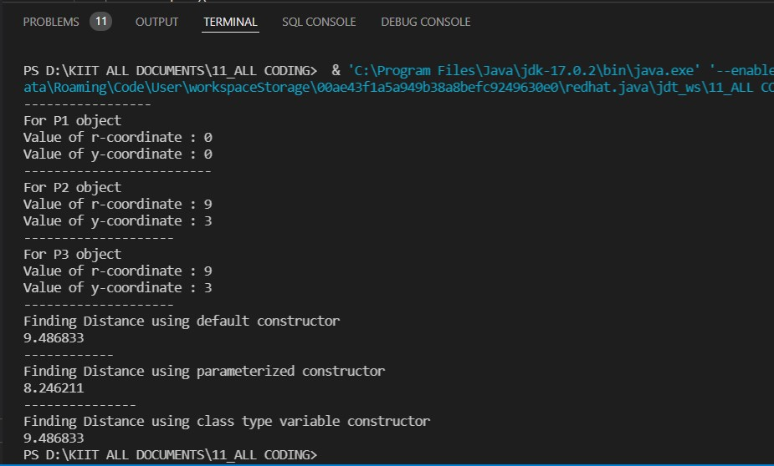

**QUESTION 2:-** Implement a class Rational having data members num and denum. Include appropriate constructors. Also include the following methods

1. Rational add(Rational):- is used to add two rational objects.
2. Rational subtract(Rational):- is used to subtract two rational objects.
3. Rational mul(Rational):- is used to multiply two rational objects.
4. Rational divide(Rational):- is used to divide two rational objects.
5. boolean isEqual(Rational):- is used to check two rational objects are equal or not.
6. void show() display the rational object in “num/denum” form.

Also implement an application class RationalDemo where the

functionality of Rational class is tested.

* **CODE FOR QUESTION 2:-**

import java.util.Scanner;

class rational{

int num;

int denum;

rational(int r,int s){

num=r;

denum=s;

}

rational add(rational r11)

{

rational res=new rational(0,0);

res.num=0;

res.denum=0;

res.num=(num*r11.denum)+(r11.denum*num);

res.denum=denum*r11.denum;

return res;

}

rational subtract(rational r11)

{

rational res =new rational(0,0);

res.num=0;

res.denum=0;

res.num=(num*r11.denum)-(r11.denum*num);

res.denum=denum*r11.denum;

return res;

}

rational mul(rational r11)

{

rational res=new rational (0,0);

res.num=num*r11.num;

res.denum=denum*r11.denum;

return res;

}

rational divide(rational r11)

{

rational res=new rational (0,0);

res.num=num*r11.denum;

res.denum=denum*r11.num;

return res;

}

boolean check(rational r11)

{

if(num/denum==r11.num/r11.denum)

{

return true;

}

else

{

return false;

}

}

void show()

{

System.out.println(num+"/"+denum);

}

}

public class rationalDemo {

public static void main(String [] args){

int n1,n2,m1,m2;

System.out.println("Input two values for r1 class");

Scanner input=new Scanner(System.in);

n1=input.nextInt();

n2=input.nextInt();

System.out.println("Input two values for r2 class");

m1=input.nextInt();

m2=input.nextInt();

rational r1=new rational(n1,n2);

rational r2=new rational(m1,m2);

rational Add_res;

Add_res=r1.add(r2);

// value return

rational Sub_res;

Sub_res =r1.subtract(r2);

// value return

rational mul_res;

mul_res=r1.mul(r2);

//

rational div_res;

div_res=r1.divide(r2);

System.out.println("The value of r1: "+r1.num+"/"+r1.denum);

System.out.println("The value of r2: "+r2.num+"/"+r2.denum);

if(Add_res.num==0){

System.out.println("The sum of r1 and r2: 0");

}

else{

System.out.println("The sum of r1 and r2: "+Add_res.num+"/"+Add_res.denum);

}

if(Sub_res.num==0){

System.out.println("The difference of r1 and r2: 0");

}

else{

System.out.println("The difference of r1 and r2: "+Sub_res.num+"/"+Sub_res.denum);

}

if(mul_res.num==0){

System.out.println("The product of r1 and r2: 0");

}

else{

System.out.println("The product of r1 and r2: "+mul_res.num+"/"+mul_res.denum);

}

if(div_res.num==0){

System.out.println("The division of r1 and r2: 0");

}

else if(div_res.num==div_res.denum){

System.out.println("The division of r1 and r2: 1");

}

else{

System.out.println("The division of r1 and r2: "+div_res.num+"/"+div_res.denum);

}

}

}

**OUTPUT FOR THE QUESTION 2:-**

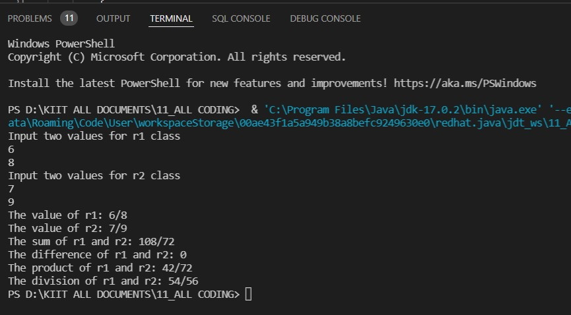

**END**